**FLEET APP version 1.3 CONCERNS**

Legend

-Ok na

-Previous concern na hindi pa ok

-New concern

1. Pwede po bang pa try ng naka connect na talaga sa API ng SAP.

# Logistics Head

1. Delivery Order

* Nudge – once you click Create Order, the recipient from the nudge is different from the delivery order.

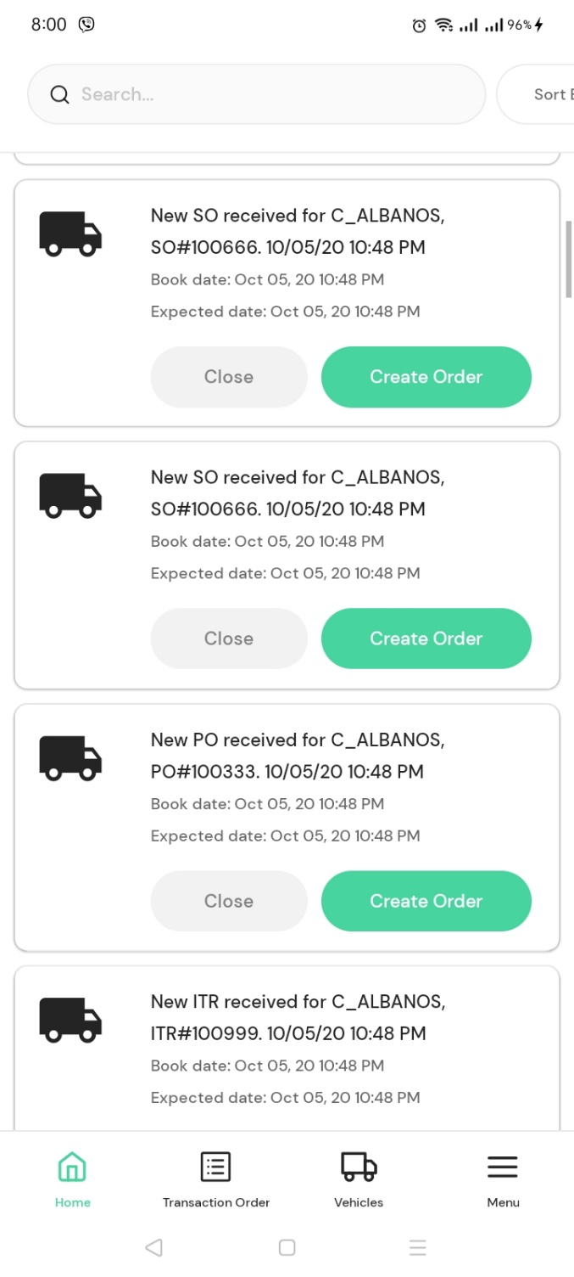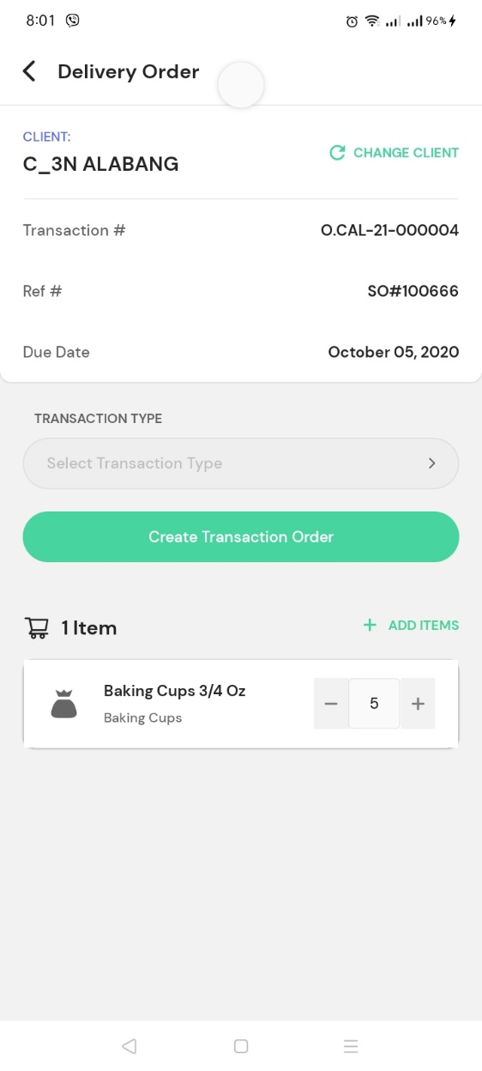

* Create order

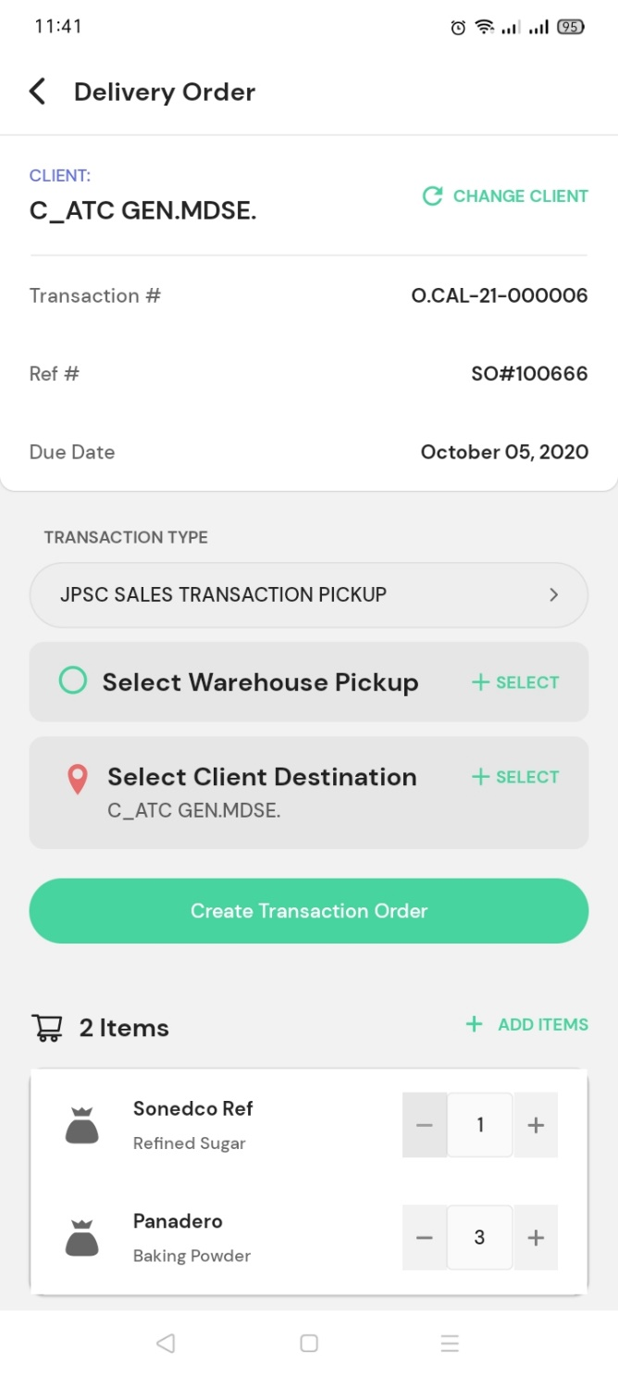

12 Transaction types

List of warehouses (in database – whsename from tblwhse where status=’1’)

List of poi under that client (in database – poiname, address from tblpoi where status=’1’)

List of customers (in database – customer from tblcustomer where status=’1’)

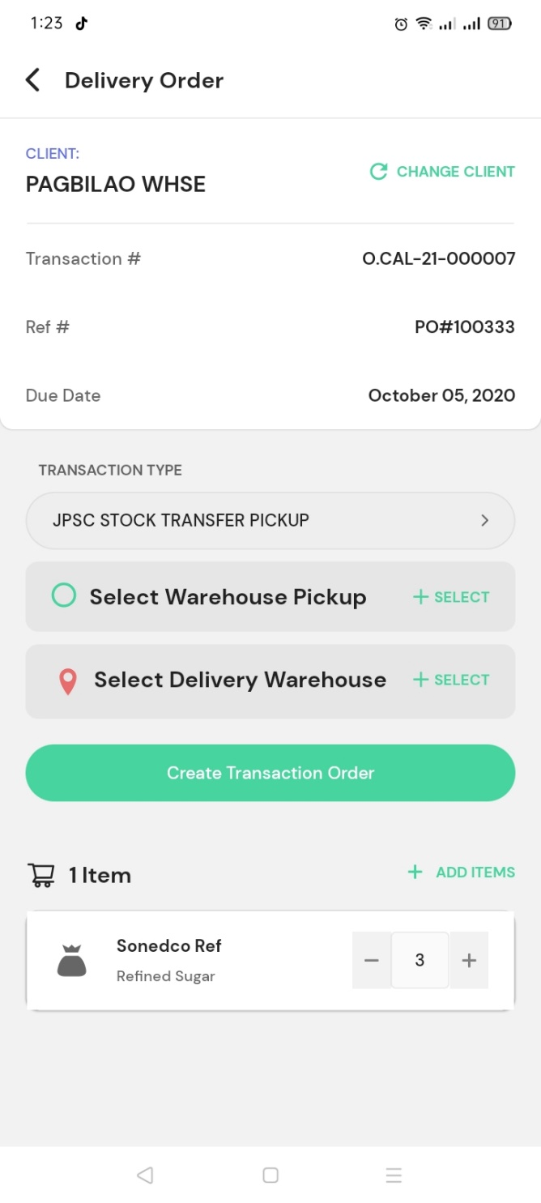

12 Transaction types

List of warehouses (in database – whsename from tblwhse where status=’1’)

Anu pong purpose nito at bakit sa sales transaction walang ganito.

Bakit walang Select Client Destination?

List of customers (in database – customer from tblcustomer where status=’1’)

* Select Client Destination, once i-click ito puro C_pce Trading ang lumalabas na POI name, pero pag nag select saka lang makikita kung anung POI name talaga. Dapat sa list ng client destination, POI name ang nakalagay.

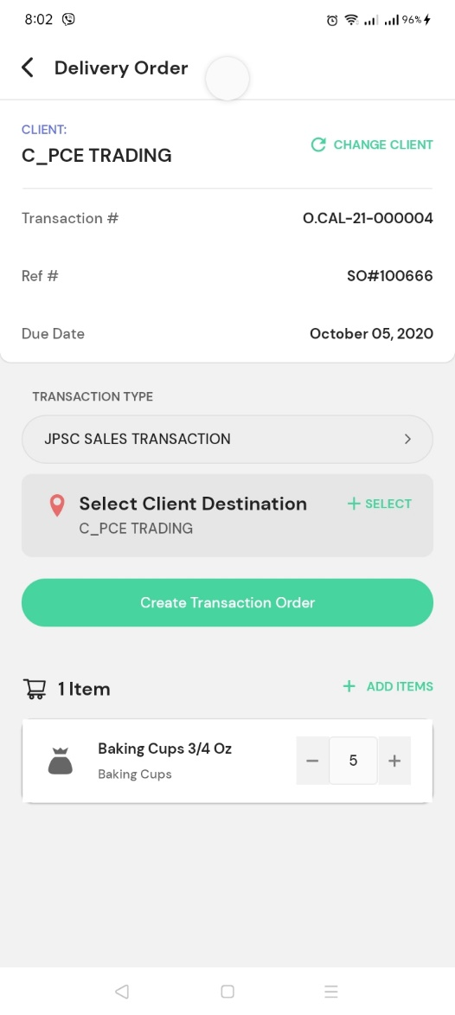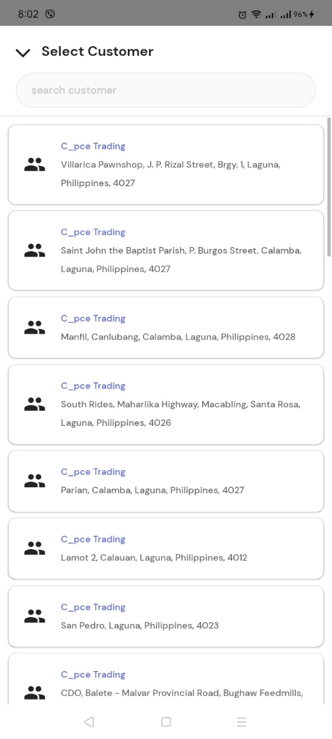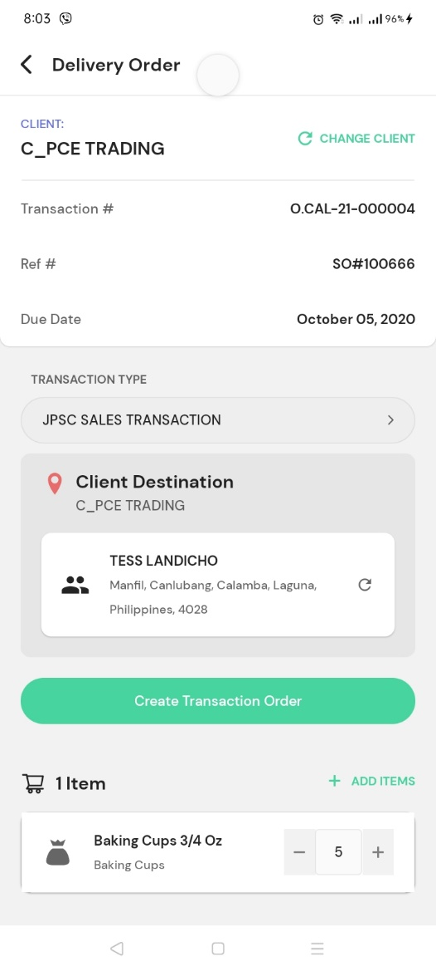

* Creating order vs Delivery details

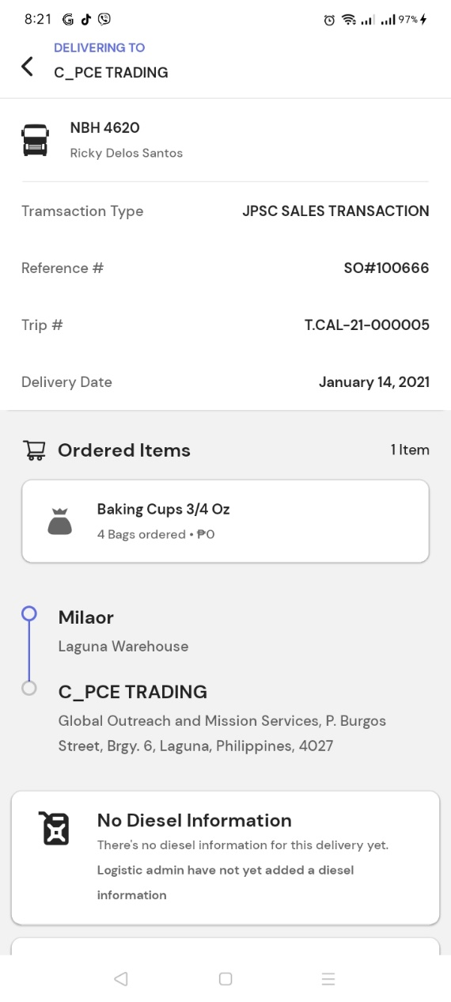

Iba ang address na lumalabas sa delivery details

Paano nagkaroon ng Milaor? Walang sinet na ganito sa pag create ng order.

* No option to remove item. Zero count.
* How to cancel created order transaction.

1. Create Delivery

* Hindi nakikita sa In Process ang Plate# at Trip#
* Select vehicle, need pa mag select ng vehicle type bago maselect yung vehicle.
* Nakakapag add ng maraming vehicle sa isang order transaction. Baliktad po, dapat nakakapag add ng isa o maraming order transaction sa isang vehicle.
* Creating trip vs Created Trip details

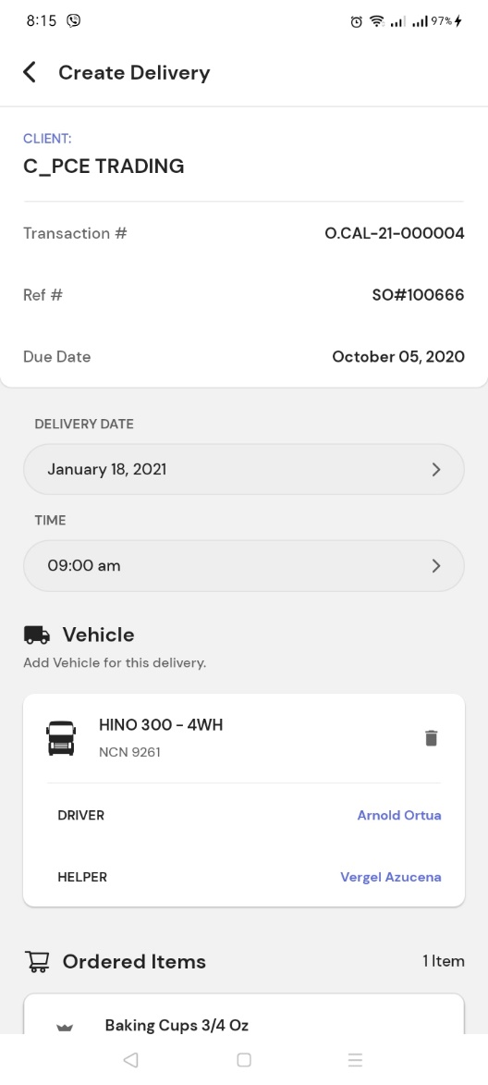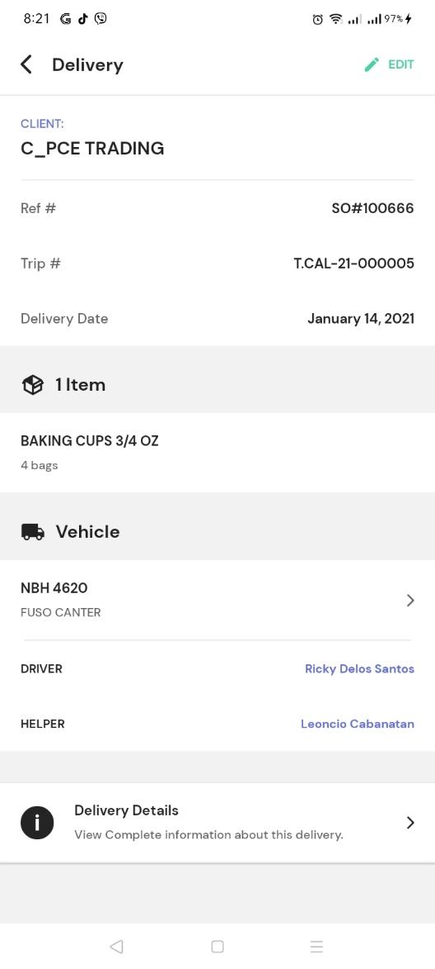

* Wala pang multiple transactions in one trip.
* Cannot Edit details. Once i-click ang Edit, bumabalik lang sa In Process.
* Delivery details. Departure is already marked as Done kahit hindi ko pa po ginagalaw yung departure nito. Pag click ng Departure status, ang nakalagay is previous date pa nadeparture.

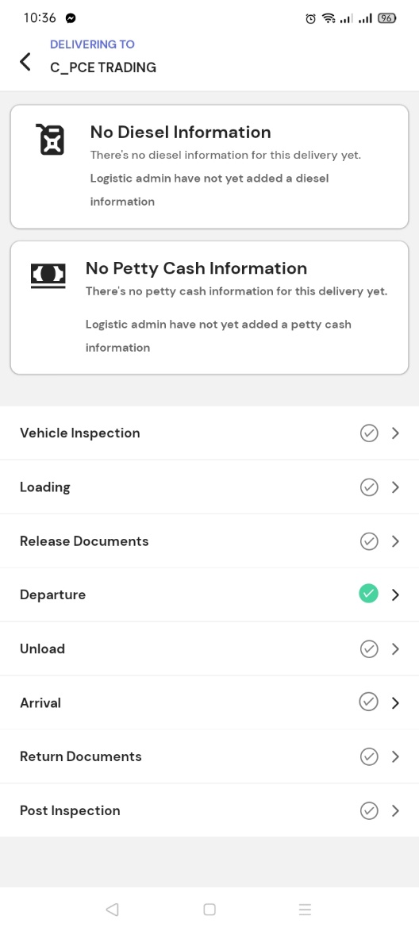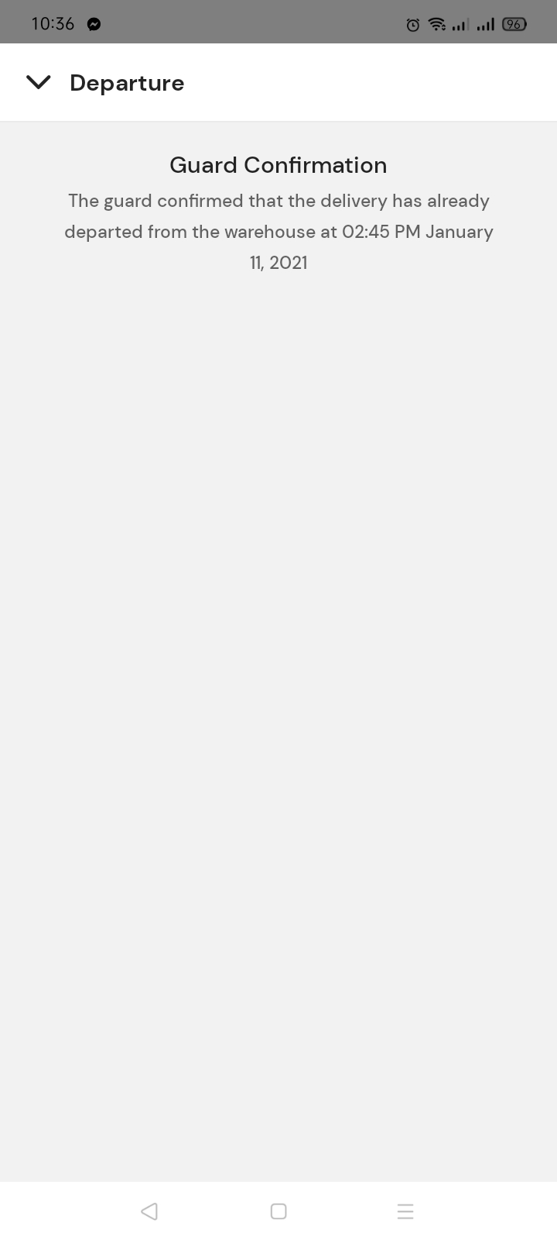

# Logistics Admin

Note: Ang ginamit dito is mismong Logistics Admin account.

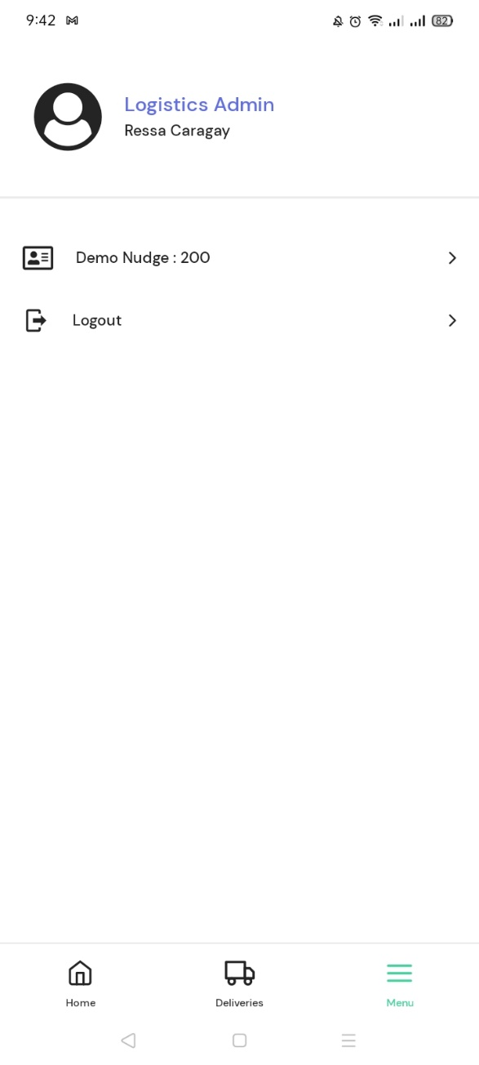

1. 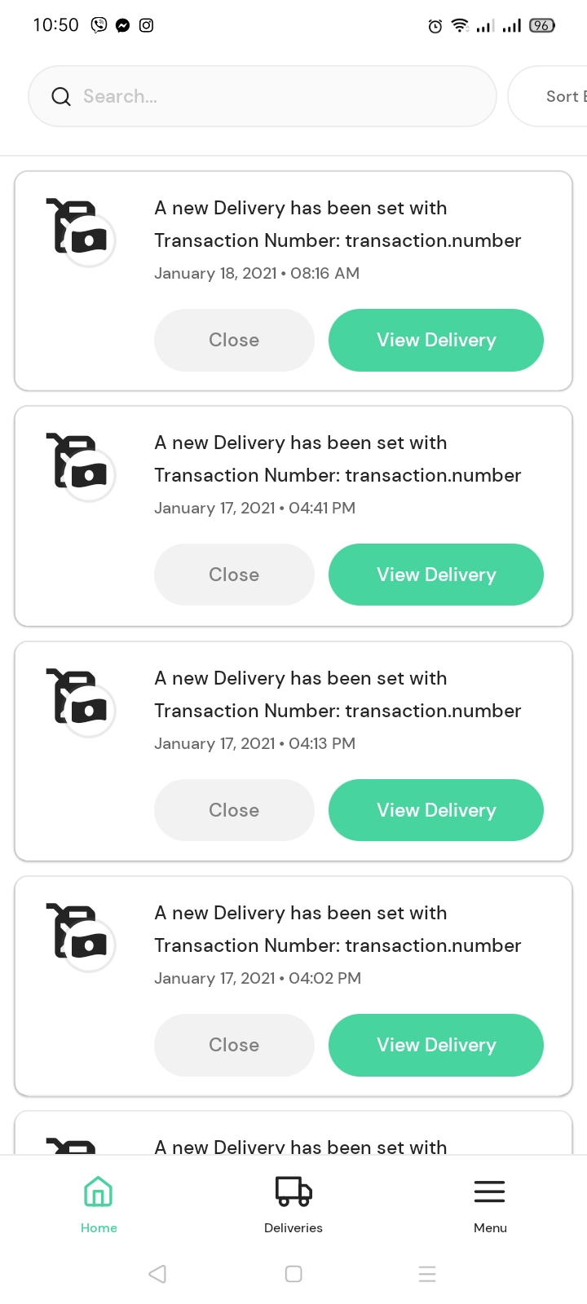Logistics Admin Nudge. Date and time created ang lumabas instead na delivery date and etd.

* Details na dapat nasa nudge.

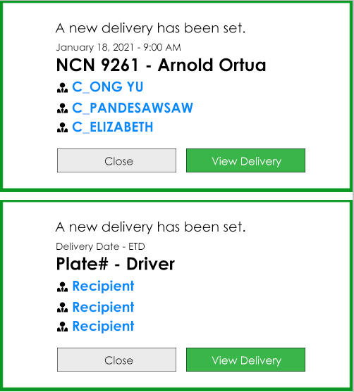

1. Pwede po bang magkaroon ng filter sa Deliveries -> Upcoming, kung anung steps sya pending, kasi example Logistics Admin account pero ang hawak nya lang is Release Documents, mas mabilis kung may filter, para ang makikita nya lang ay yung mga hindi pa narerelease ang documents.

(Diesel, Release Documents, Release Petty Cash, Return Documents) Color coding.

1. Pagka click ng Truck sa Upcoming, Doble yung Plate#.

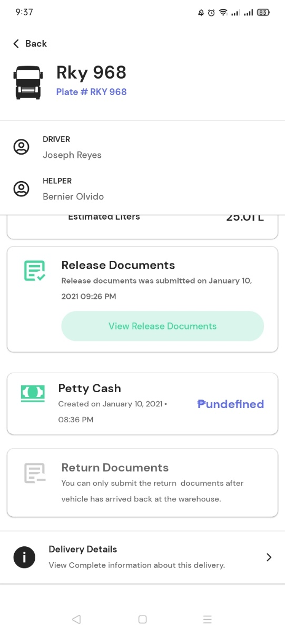

1. Create diesel

* Lagyan ng time start
* Ipakita kung anung vehicle type.
* Wala pa yung field ng additional diesel kung saan pwedeng input manually ng dagdag na diesel si user.
* Wala pang remarks na field.

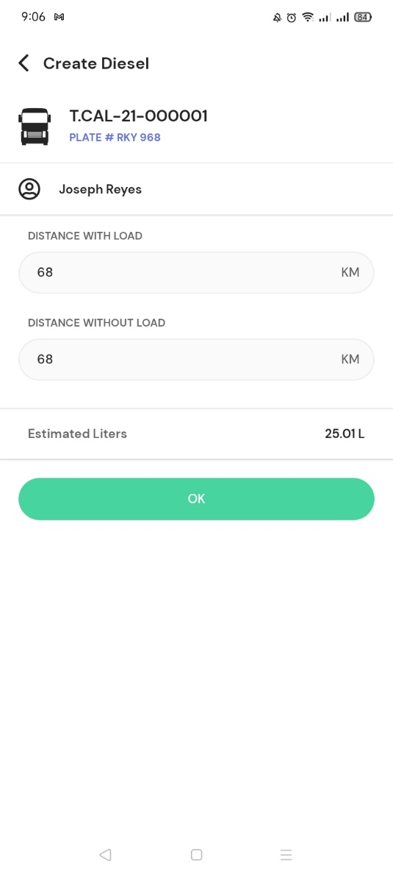

* Hindi dapat makakapag Create Diesel kung hindi pa tapos ang Pre-Inspection dahil sa pag compute ng diesel need ng Actual beginning diesel.

1. Release Documents

* Nakapag Release Documents kahit hindi pa tapos ang Loading.
* Hindi maka capture ng multiple Delivery Receipts.
* 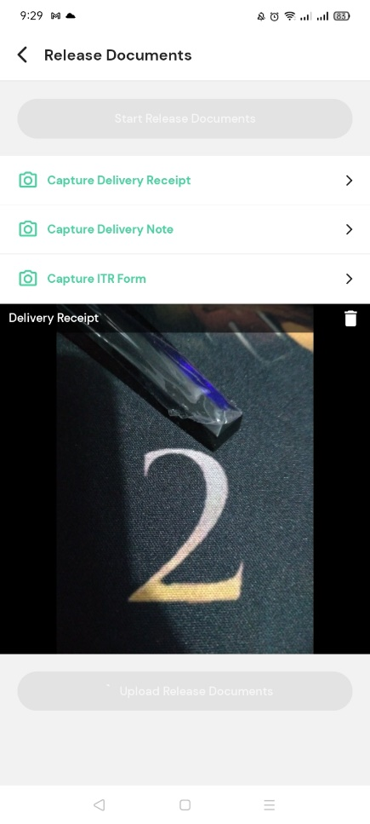Walang field kung saan mag iinput ng AR#, DR#, RDR#, DN#
* Nag capture ako ng 1 DR, 1 DN at 1 ITR, then, click Submit, pag View ng Release Documents, ITR lang yung nag show.

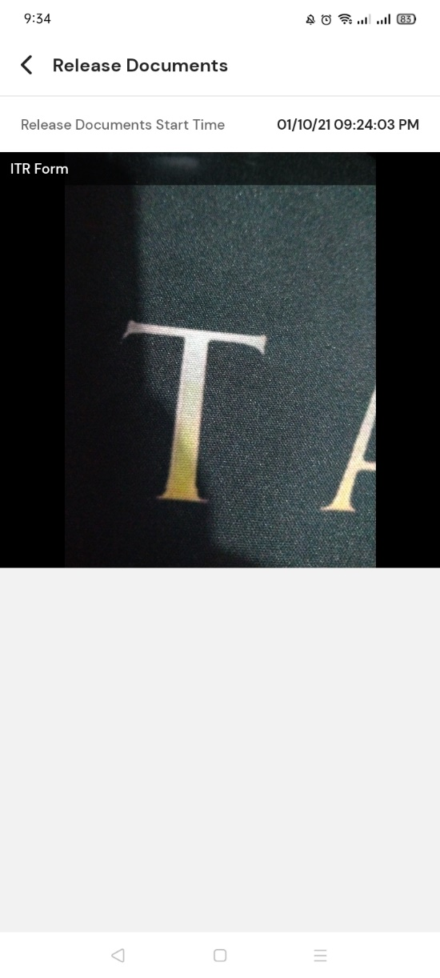

1. Create Petty Cash

* Lagyan ng time start
* Ipakita anung vehicle type.
* Walang details na nilagay pero na ki-click yung Create.

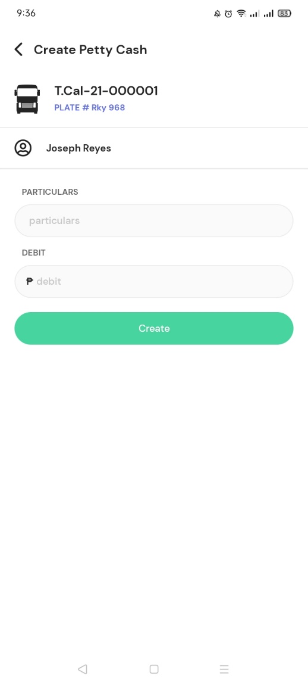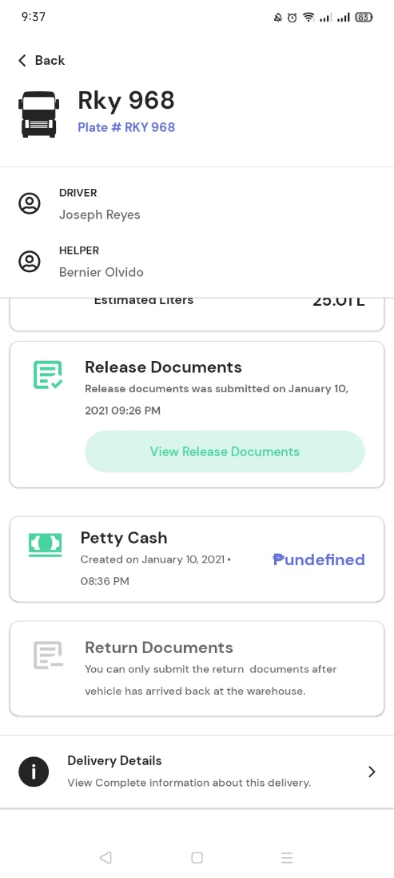

1. Return Documents

* Dapat pwede din mag capture ng Delivery Receipts.
* Hindi maka capture ng multiple documents.
* 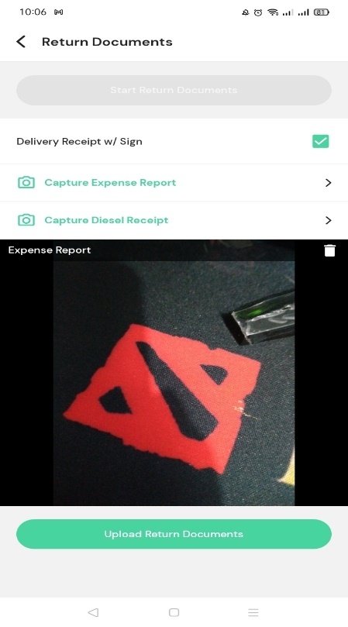Walang field kung saan mag iinput ng AR#, DR#, RDR#, DN#, ITR#, IT#, GRPO#.
* Saan makikita kung kalian na upload ang mga picture?

1. Nakailang Log out tapos Log in, biglang tumama yung Address sa Delivery Details, pero hindi naka show yung POI name.

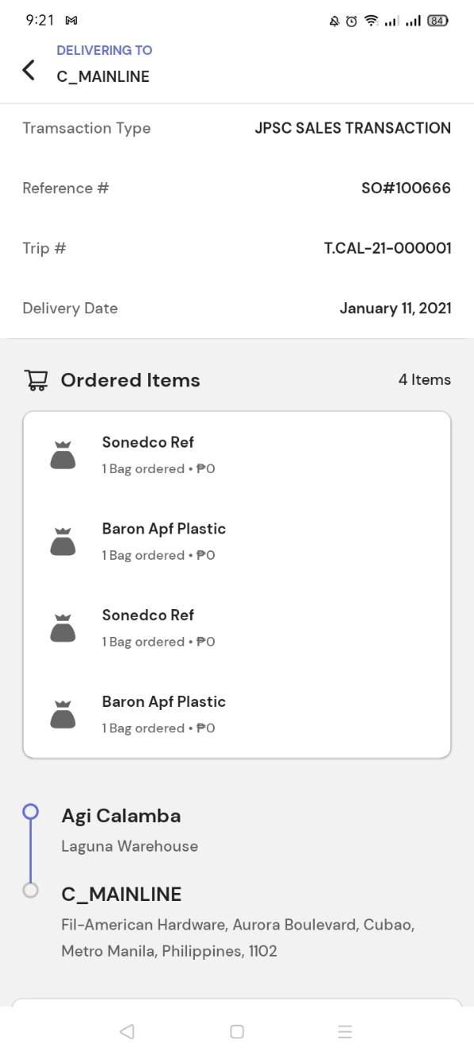

# Inspector Checker

Note: Ang ginamit dito na account is Inspector Checker.

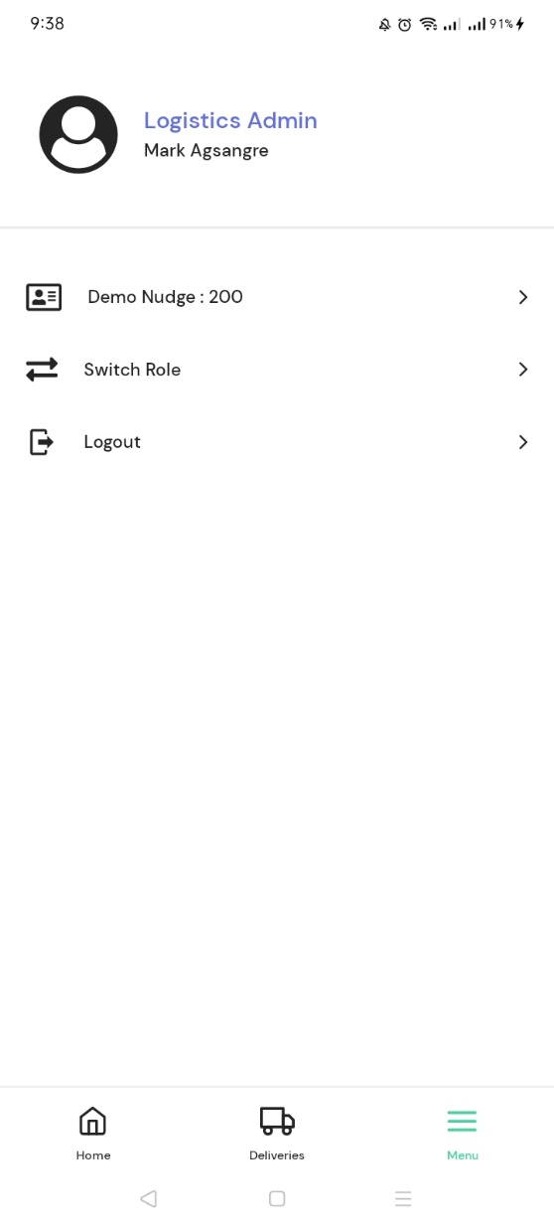

1. Ipakita ang Trip# at Vehicle Type

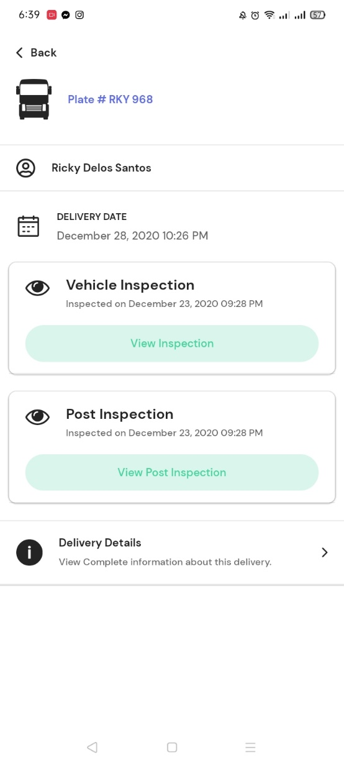

Trip#

VEHICLE TYPE

1. Pag select ng truck sa Inspections -> Pending;

* Ipakita ang vehicle type.
* Tapos na ang Pre-Inspection at Post Inspection pero nasa list pa din ng Pending.
* Hindi na click ang Start pero naka pag Done ng Inspection.

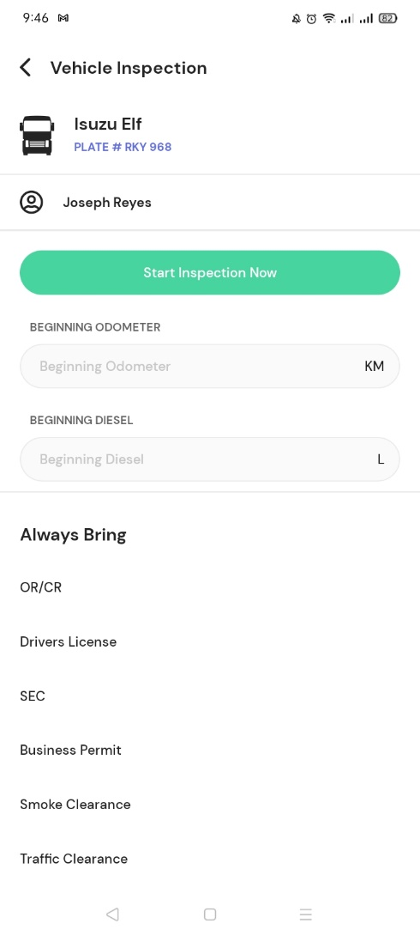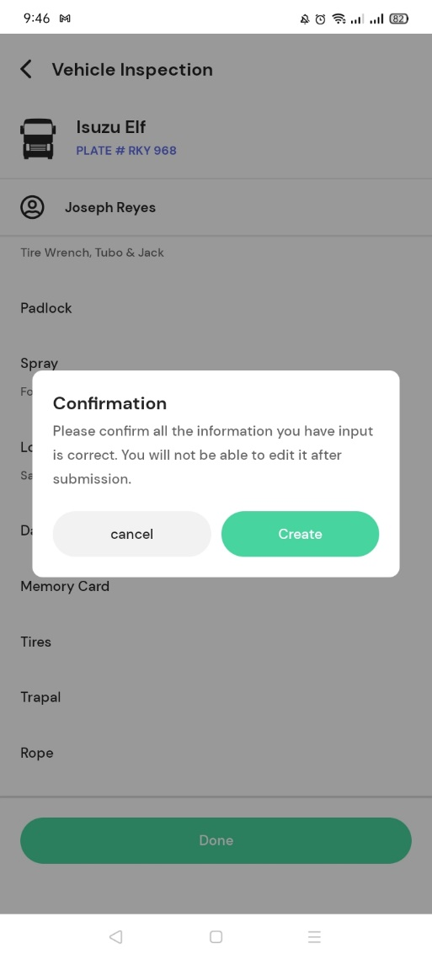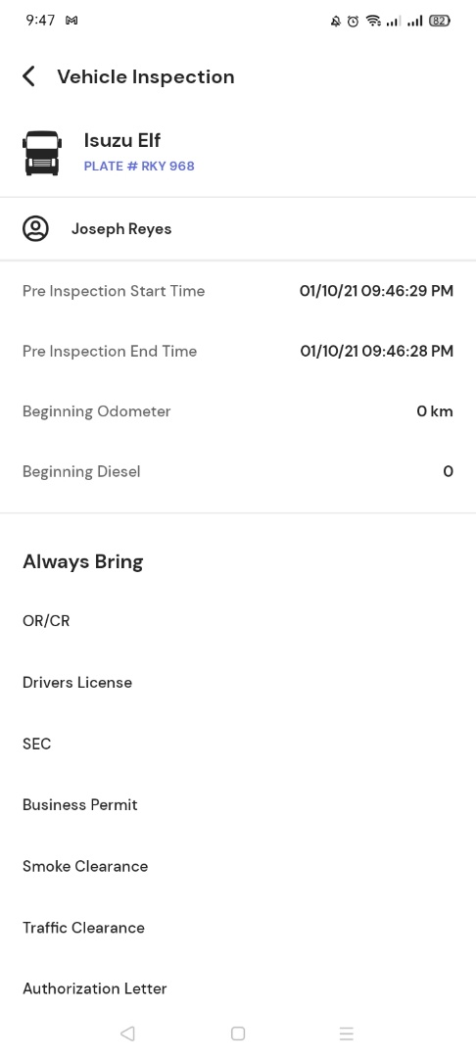

* Inspected by. Doble yung name.

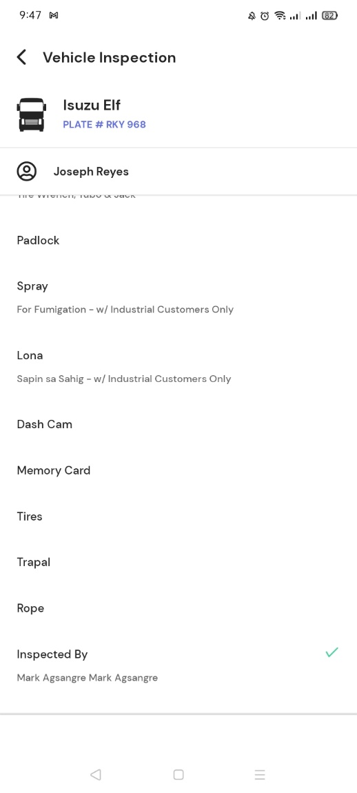

* Pag click ng View Post-Inspection, ang lumalabas na label ay Pre-Inspection.

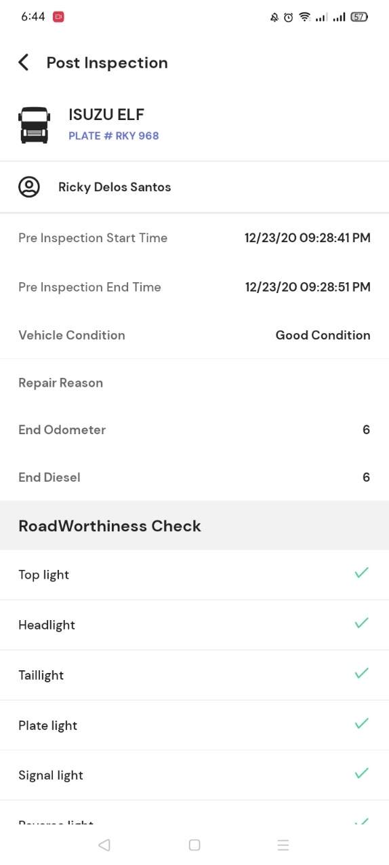

* Nakakapag Post-Inspection agad kahit hindi pa na Pre-Inspect. Dapat makakapag Post-Inspection lang if naka arrive na.

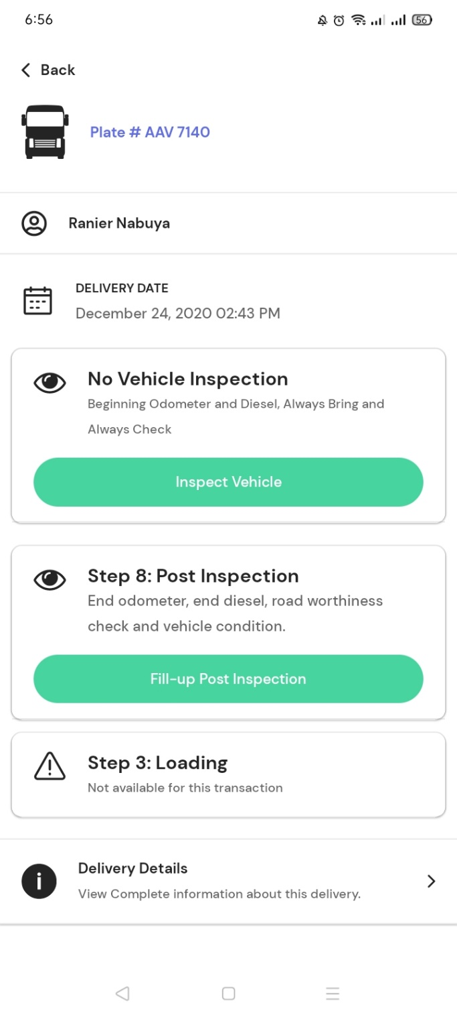

* Mayroong mga trips na hindi maka pag Post Inspection.

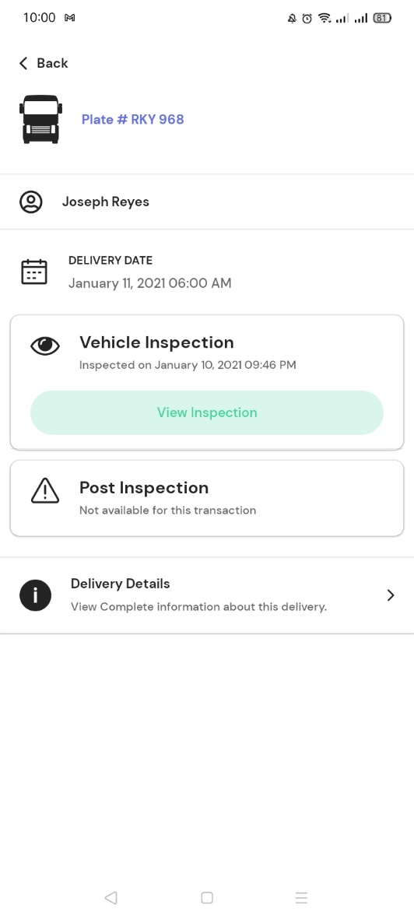

* Alisin na yung Roadworthiness Checklist sa Post Inspection dahil nasa Motorpool Inspection app na po ito.

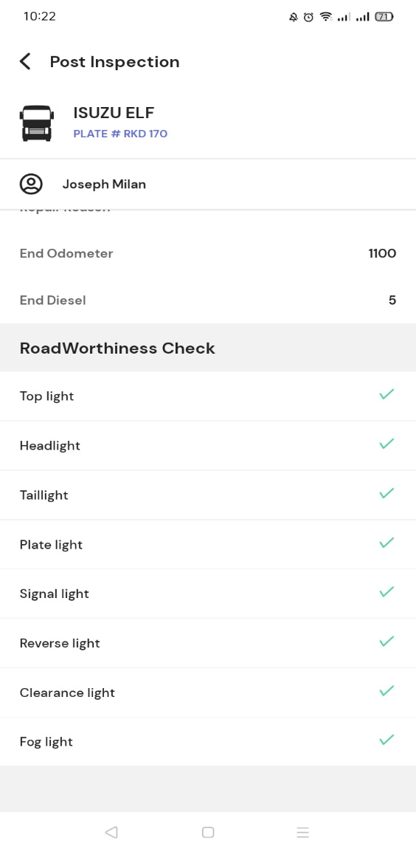

1. Walang lumalabas sa Done

# Warehouse Checker

Note: Ang ginamit na account dito is talagang Warehouse Checker.

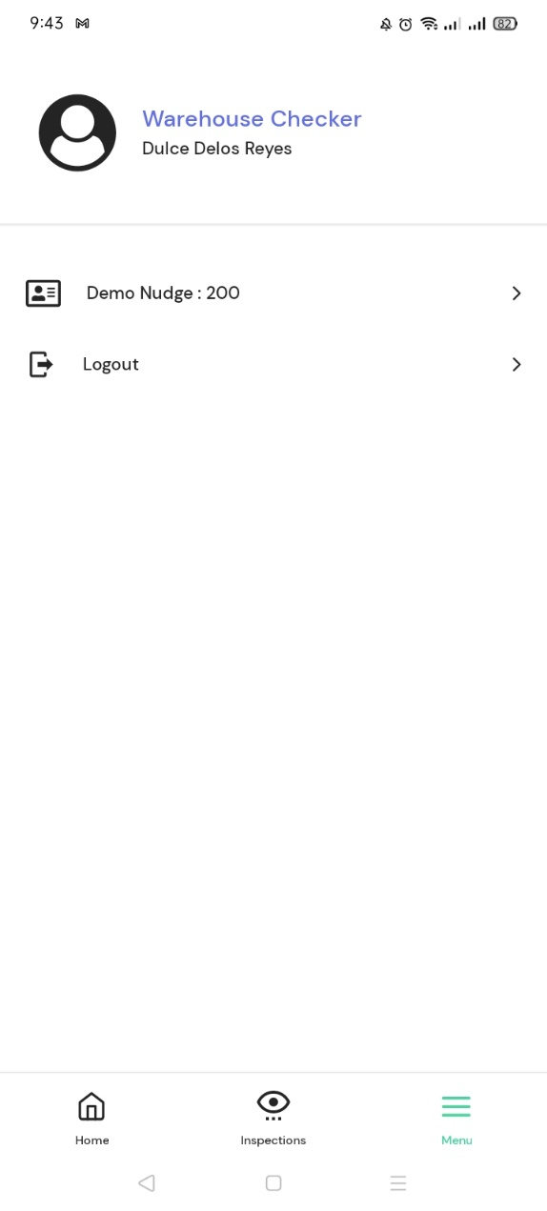

1. Cleanliness checklist. Hindi na Start pero naka pag Done.

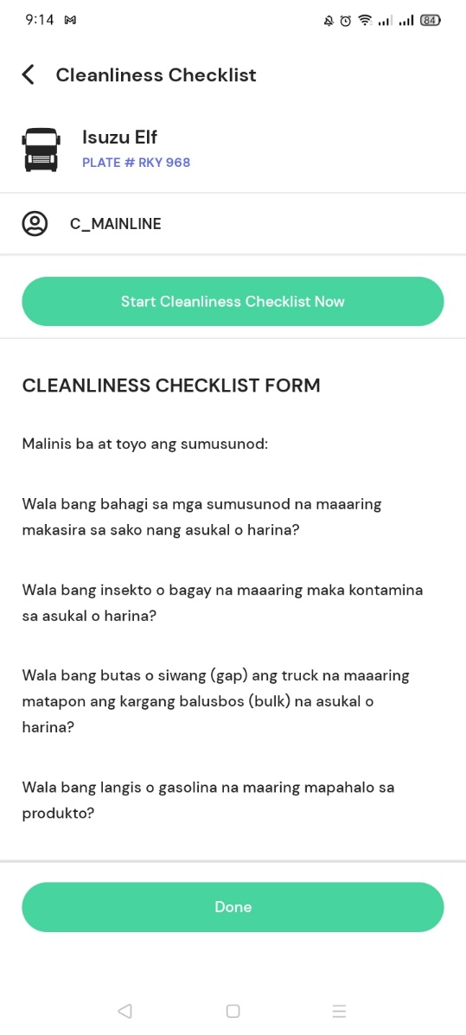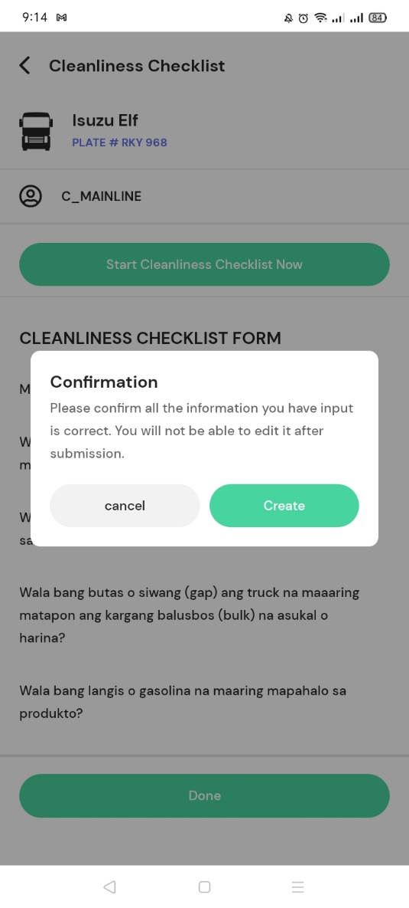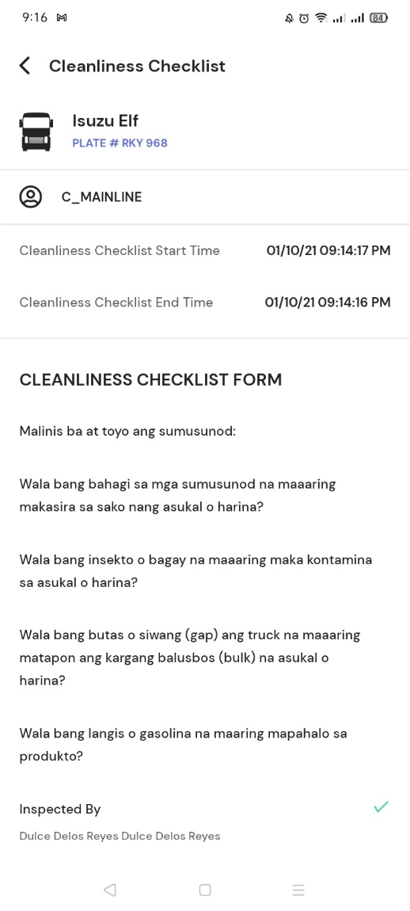

1. Inspected by. Doble name ang lumabas.
2. Ipakita ang trip#.
3. Dapat hindi ma Start Loading if hindi pa tapos ang Pre-Inspection.
4. Loading. Pag click ng Loading, ipakita yung Recipient at Reference#.
5. View Loading Information. Pre-Inspection yung label sa time start and end.

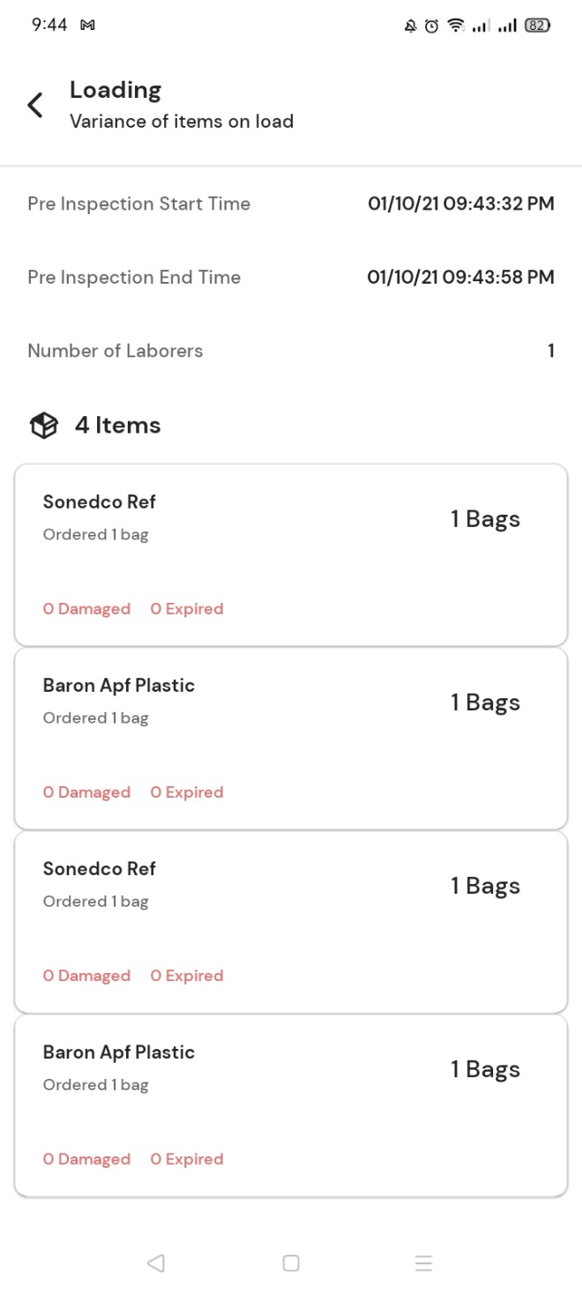

1. Lumalabas ang Post Inspection. Dapat kay Inspector checker lang ito llalabas.

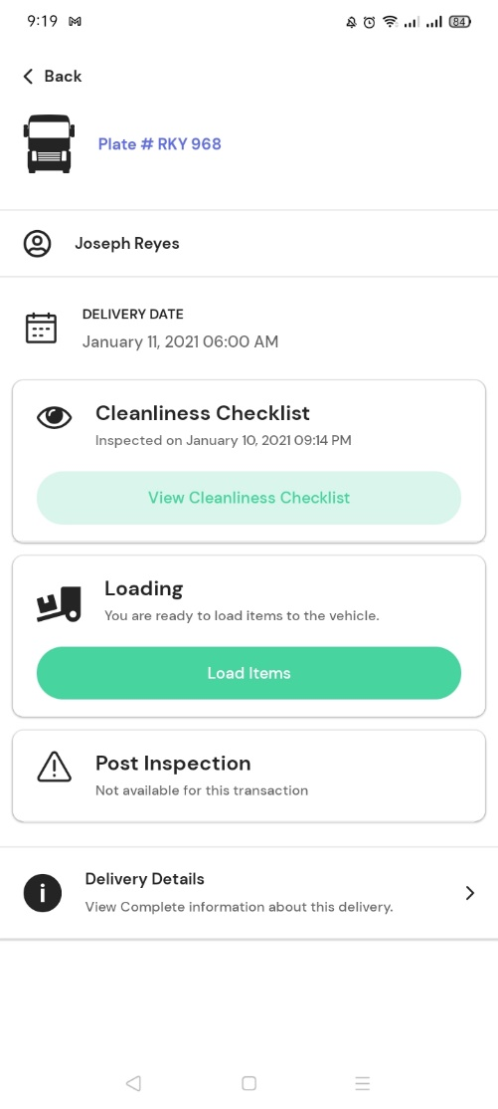

1. Nasa list pa din ng Pending kahit tapos na ang Cleanliness Checklist at Loading.
2. Walang lumalabas sa Done.

# GMP Checker

1. Ipakita ang Trip#.
2. Nasa list pa din ng Pending kahit tapos na mag checklist.

# Guard

1. Magkaroon ng filter, kung hindi pa na departure or kung hindi pa na arrival.
2. Nade-Departure kahit may hindi pa tapos sa Pre-requisites (sa trip na to hindi pa nagawa ang GMP Checklist).
3. Alisin yung Delivery Details sa Guard.

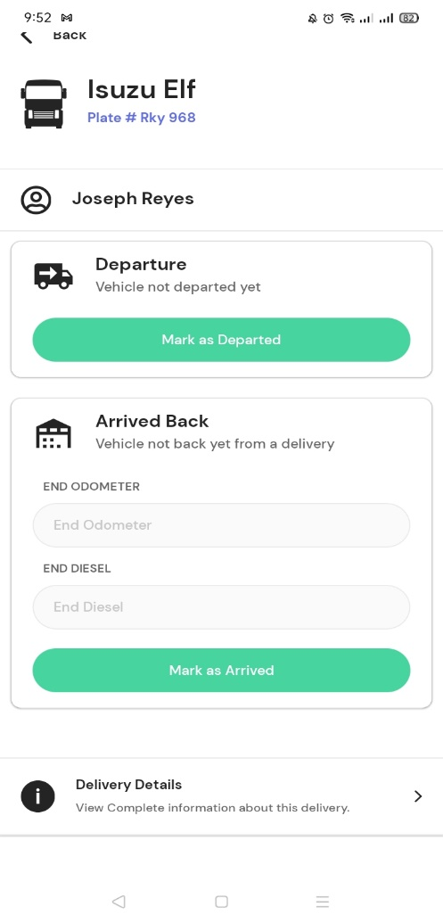

1. Na departure at na arrival na yung truck pero nasa Upcoming pa din.
2. Alisin ang ending odometer at ending diesel kay Guard, nasa Post-Inspection na yan ni Inspector Checker.

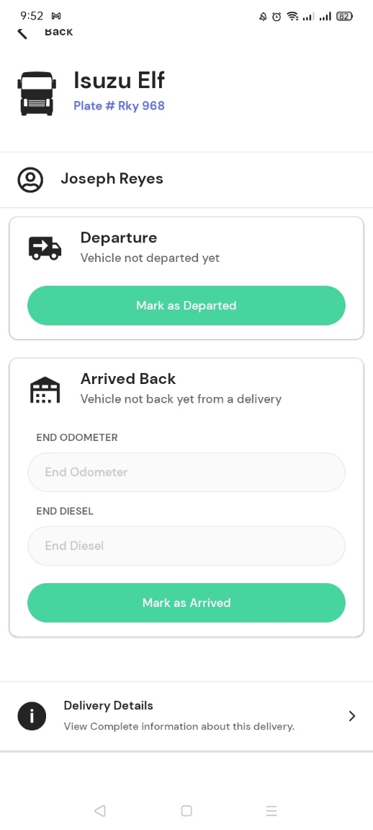

1. Vehicle not departed yet pero nama-Mark as Arrived.

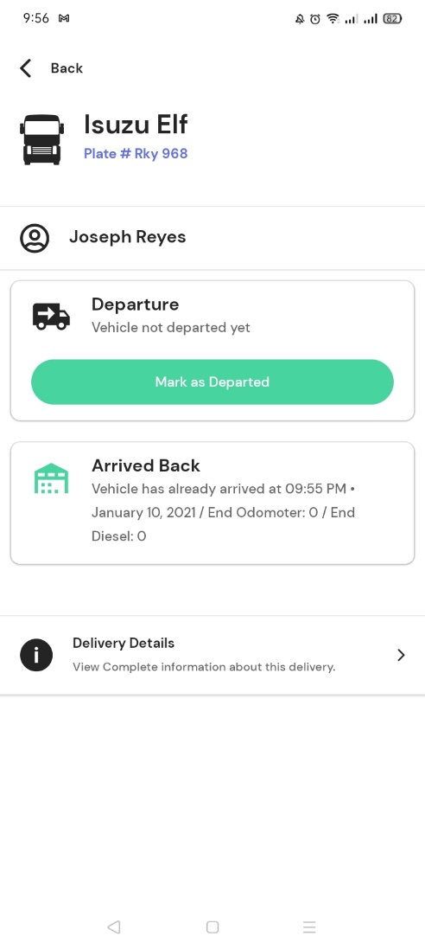

1. Papadagdag ko po sa pag arrival, since nagagamit na sa warehouse yung motorpool inspection app. Once na arrival, mag a-add lang ng details sa another table (tblmscheckup). Sa table na yun kumukuha ng details ang motorpool inspection app para sa list ng **For Inspection Trucks**.

# Driver

Note: Ang ginamit dito na account is driver talaga.

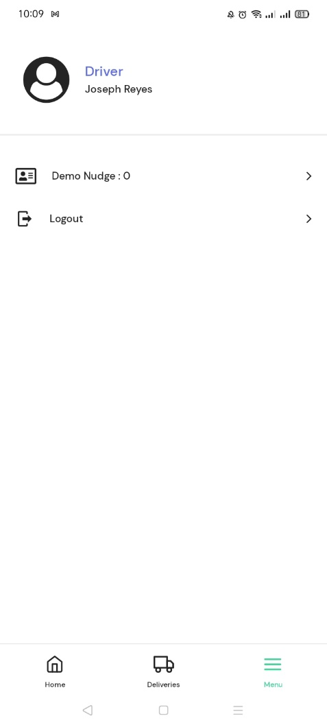

1. Driver Nudge. Di nag show ung Trip#. Date and time created ang lumabas instead na delivery date and etd.

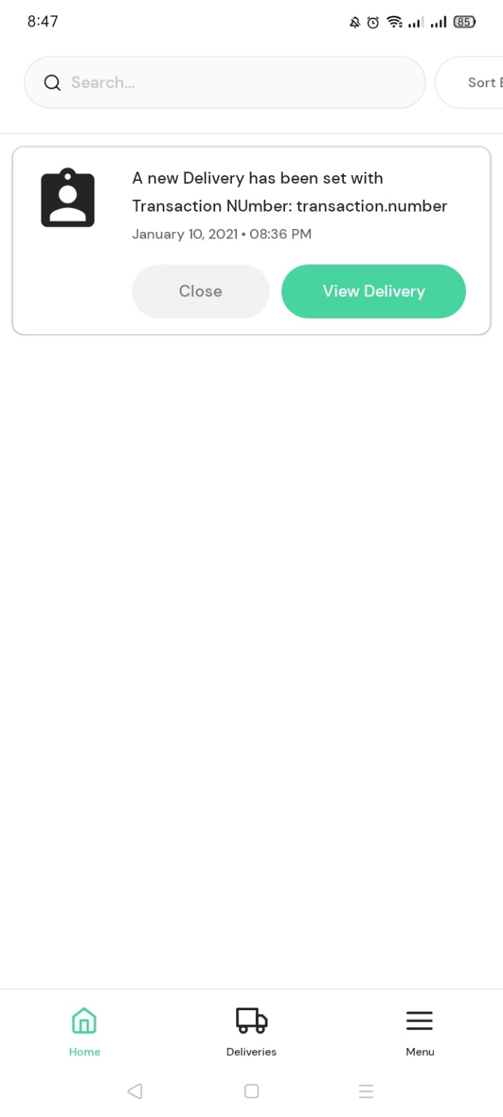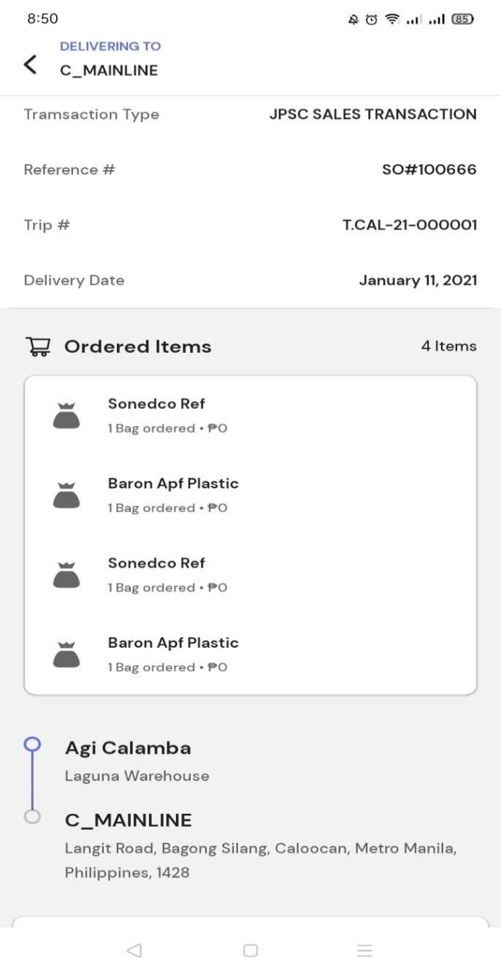

1. Once na click ang View Delivery, mali ang address na lumalabas.

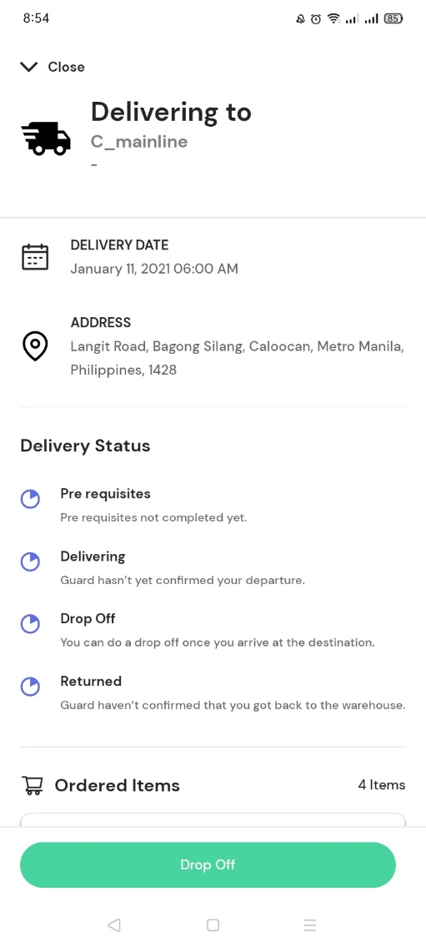

1. Ang makikita nya lang dapat sa Deliveries ay yung mga byahe nya.

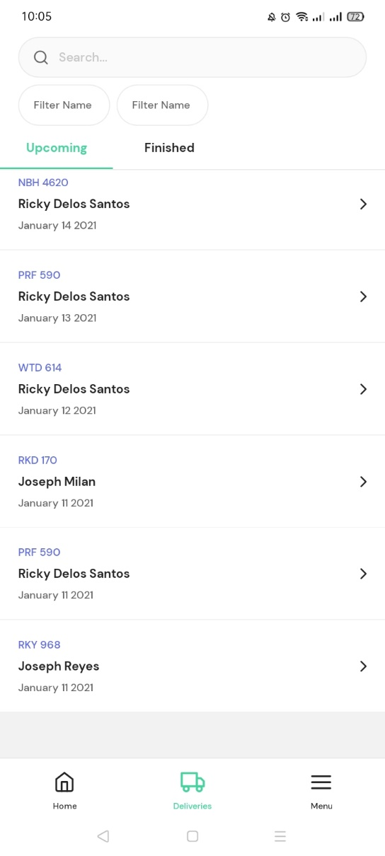

1. May address na sa taas, may address ulet sa baba.

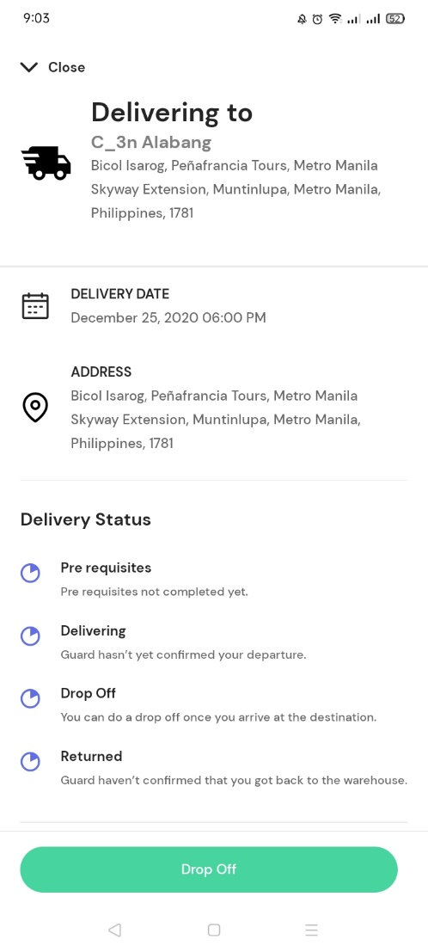

1. Drop off. May nakagalay na not yet unloaded, pero hindi ko makita panu i-process yung unloading sa app kaya nag capture receipt lang pero na confirmed na agad yung Drop off kahit hindi na unload.

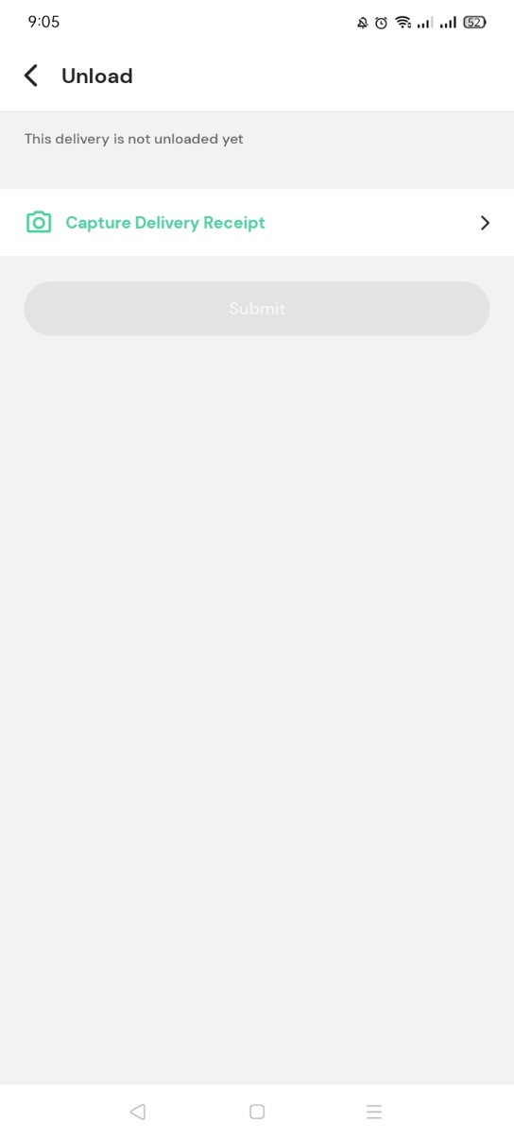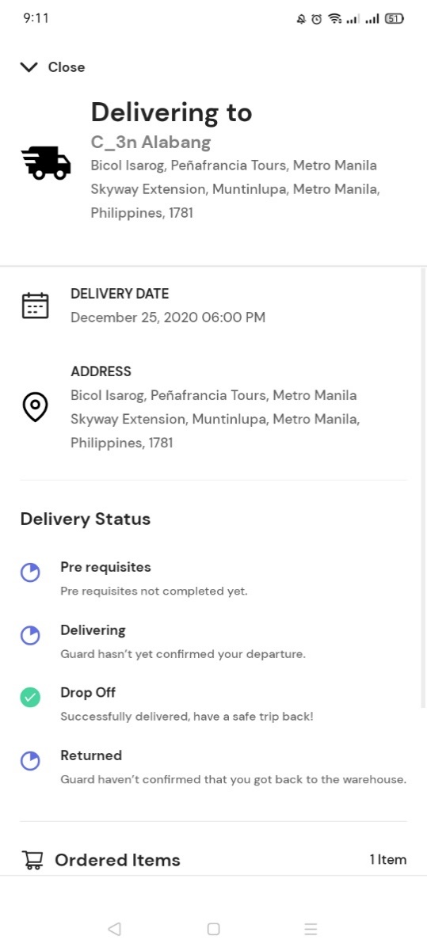

After masubmit ng picture kahit hindi pa na unload, nag ok na yung drop off

* Hindi pa na set yung delivered quantity, pero naka indicate na Delivered. Not yet unloaded pero naka indicate na Delivered.

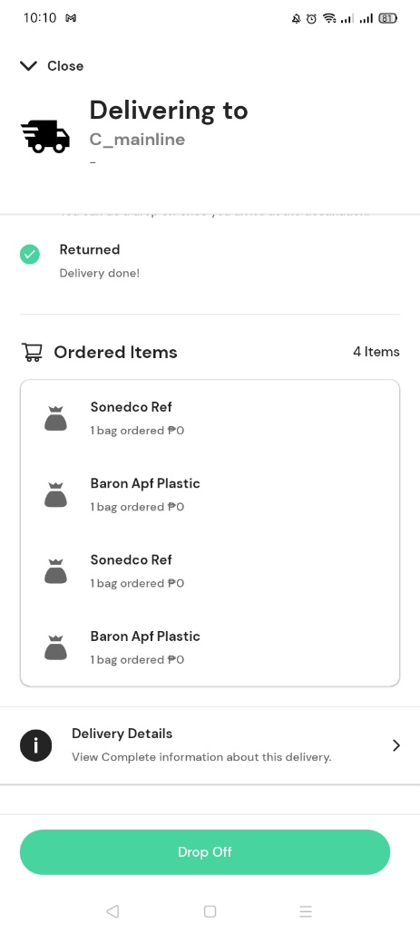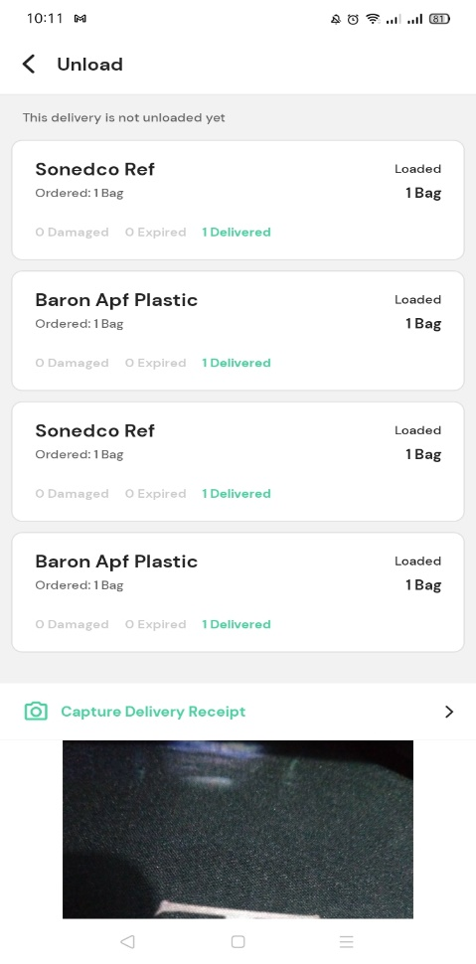

* Cannot capture multiple delivery receipts.
* Naka numeric yung field ng Reason.

